

## Group Members

|  |  |
| --- | --- |
| **NAME:** | **ROLL NO** |
| **SAIF ALI** | **Bcsm-f21-285** |
| **JAVERIA MUMTAZ** | **Bcsm-f21-224** |
| **ARIBA NAZ** | **Bcsm-f21-278** |

**Section: 5---B**

**Research Topic: User’s Experience of E-banking**

**Instructor: Mam Fizza**

**=============================================**

**User’s Experience of E-banking**

**Abstract:**

This research explores how people use online banking (E-banking) to make it better for everyone. We asked a diverse group of online banking users, including different age groups, about what they like and what can be improved. We used simple surveys to find out how users do transactions and what they want in online banking. By looking at the numbers from the surveys, we found patterns and trends in how people use digital banking.

The results of our study show us what users appreciate in online banking and where things could be made better. Our main goal is to help banks improve their online services and meet the changing needs of users in today's digital world. This research is like a guide for banks to make online banking interfaces easier and more enjoyable for everyone. We believe that understanding what users want and how they use online banking can make the experience better for everyone involved.

**Introduction:**

The coming of the internet has completely changed the way companies offer their services worldwide. It has brought many new and creative services for customers. (Sabi, 2014).[1]Banks can use the internet as powerful tools to change and improve the way they do things. Banks now offer a new kind of service using the internet, known as "Internet Banking" (IB). Internet Banking involves financial transactions conducted over the internet through a bank's website. It allows both individual and business customers to access their accounts, perform transactions, and obtain information about financial products from anywhere and at any time, as long as they have an internet connection (Shao, 2007)[2].Internet Banking enables customers to perform their banking tasks swiftly and efficiently from the comfort of their homes or workplaces. It reduces transaction costs for customers. (Dong, 2008)[3].The introduction of the internet into the banking system has brought modernization to banks (A. Farooqui and P. Rajani).[4] In today's age of advanced technology, the adoption of e-banking services plays a crucial role in assisting financial institutions in staying competitive and adjusting to the recent market changes. (P. N. Dao)[5]. The success of Internet banking relies on the maturity, integrity, and commitment of individuals. The Internet banking system has demonstrated greater versatility compared to a human (I. D. Adewuyi)[6].

**Literature Review:**

E-banking is like when new computer stuff gets mixed with regular bank stuff. The main reasons they do this are to spend less money on running the bank and make more money from it. (Sannes, R. (2001) Reibstein, D.J. (2002))[7] .Research done between 1999 and 2006 found that using e-banking can help banks do better. It makes the bank's stuff grow, spends less money on running things, and makes the bank's investments better. (. Dandapani.2008) [8]. Internet banking is becoming more popular because it's good for both the bank and the customers(Sathye, M. (1999).[9] For the bank, it helps them save money and is one of the cheapest and most efficient ways to provide services.(Robinson, G. (2000))[10].According to the Turkey banks association, 27 out of a total of 47 banks, in other words 58% of all banks in Turkey were offering internet banking services in 2006 (Banks Association of Turkey, 2006).According to Centeno in 2004, people use internet banking because it's fast, easy to use from anywhere, available all the time, and sometimes offers good deals( Centeno, C. (2004)).[11]

**RESEARCH QUESTIONS:**

* What is User’s Experience of E-banking?

**PROBLEM STATEMENT:**

We needed to study what was happening with E-Banking, what difficulties users faced. Current research doesn't focus on the exact issues that make it hard for users. This study aims to find and understand these problems. This research helped us understand E-Banking better and plan for the future.

**RESEARCH GAP:**

While many studies have looked at electronic banking (E-banking) in general, there's a lack of detailed research on how people actually feel and experience it. Most studies just talk about whether people are satisfied or not, but they don't go into the specifics of what users like or dislike about E-banking. Also, because technology is always changing, we need more up-to-date research on the latest features and interfaces in E-banking. Our study aims to fill this gap by closely examining the different aspects of user experience, providing insights that can help improve E-banking services and make them more user-friendly.

**OBJECTIVES OF THE STUDY:**

These are the research objectives for a study on E-Banking:

* Accessing user satisfaction
* Find problems that users faced while using E-banking
* Examining trust and Security Perceptions

**SIGNIFICANCE OF RESEARCH:**

The significance of this research lies in its potential to make online banking (E-banking) better for everyone. By identifying and understanding the specific issues users face, we can work towards improving the overall experience. This study aims to provide valuable insights that can lead to enhancements in E-banking platforms, making them more user-friendly and ensuring greater satisfaction for individuals using digital banking services. Ultimately, the research contributes to creating a smoother and more efficient online banking experience for users around the world.

.

**METHODOLOGY**:

The E-banking methodology relied on quantitative research methods. The target audience was E-banking users. It involved the use of purposive sampling techniques and surveys-questionnaires to gather comprehensive of digital banking. Researchers chose participants with specific traits, like age groups or online banking habits, to make sure they studied the right people. They gave these people surveys and questionnaires to fill out. These tools were incredibly helpful for collecting organized information about what users liked, how satisfied they were, and how they conducted transactions.

**DATA ANALYSIS:**

**Section A: Demographics**

|  |  |
| --- | --- |
| Age group  Forms response chart. Question title: Select your age group . Number of responses: 28 responses. | Gender  Forms response chart. Question title: Select your Gender. Number of responses: 28 responses. |
| Educational Status  Forms response chart. Question title: What is your education?. Number of responses: 28 responses. | Employment Status  Forms response chart. Question title: What&apos;s your employment status?. Number of responses: 28 responses. |

**Section B: E-banking usage**

How long have you been using E-banking services?

Forms response chart. Question title: How long have you been using E-banking services?
. Number of responses: 28 responses.

Which bank do you use primarily use for E-banking?

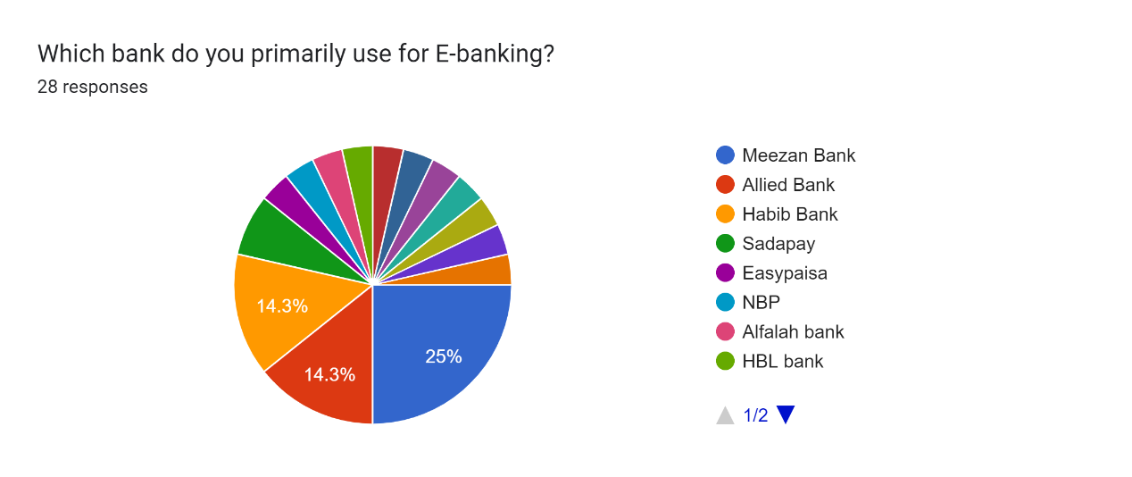

How frequently do you use E-banking services?

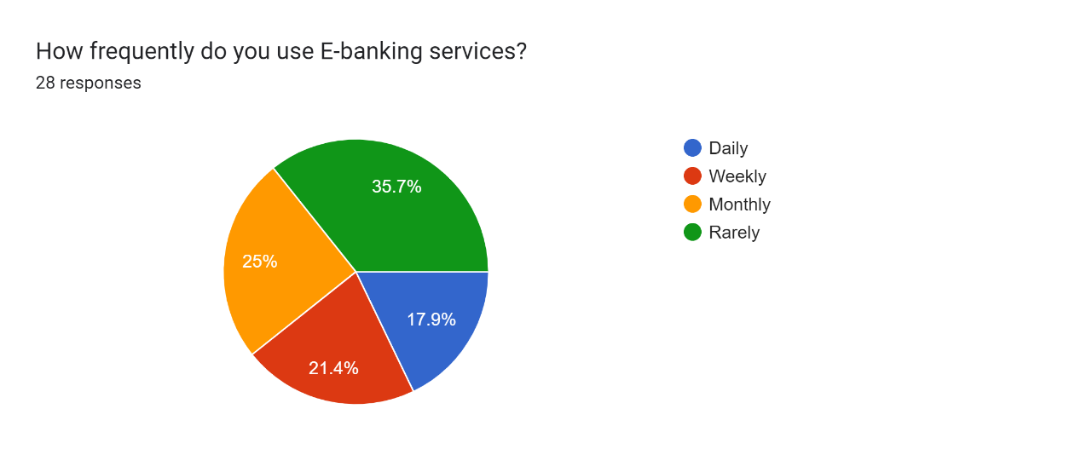

What type of E-banking services do you use?

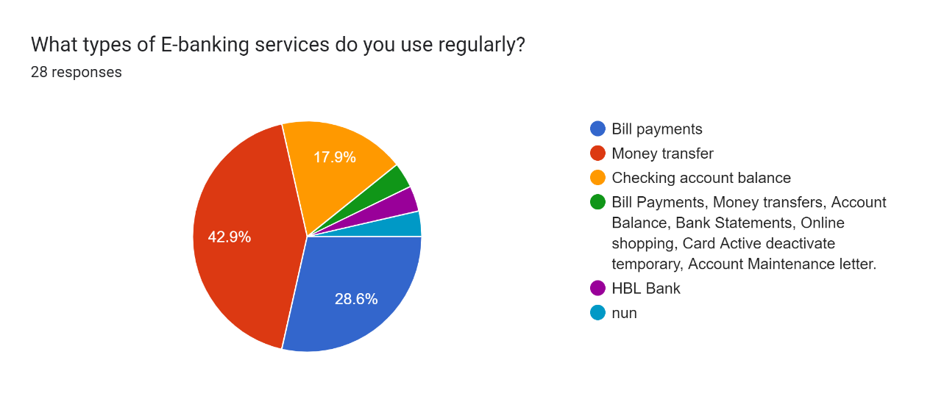

**Section C:** **User satisfaction and issue**

How satisfied are you with the user interface of your R-banking platform?

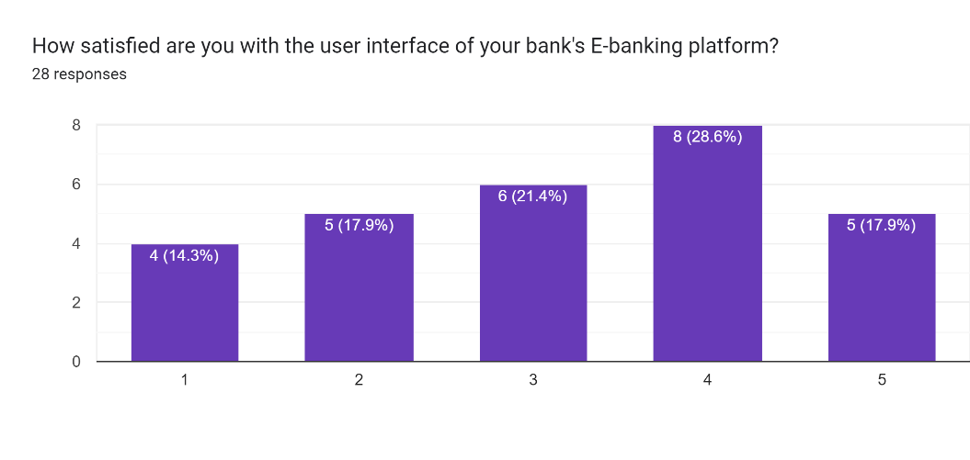

Have you encountered any usability issue while using E-banking services?

Forms response chart. Question title: Have you encountered any usability issues while using E-banking services?
. Number of responses: 28 responses.

If you say yes, then which issue you have encountered while using E-banking services?

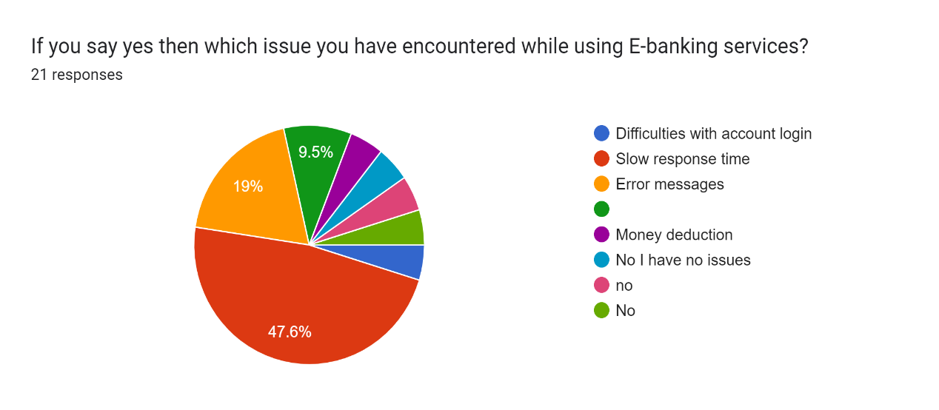

Have you faced any security concerns or issue with your E-banking services?

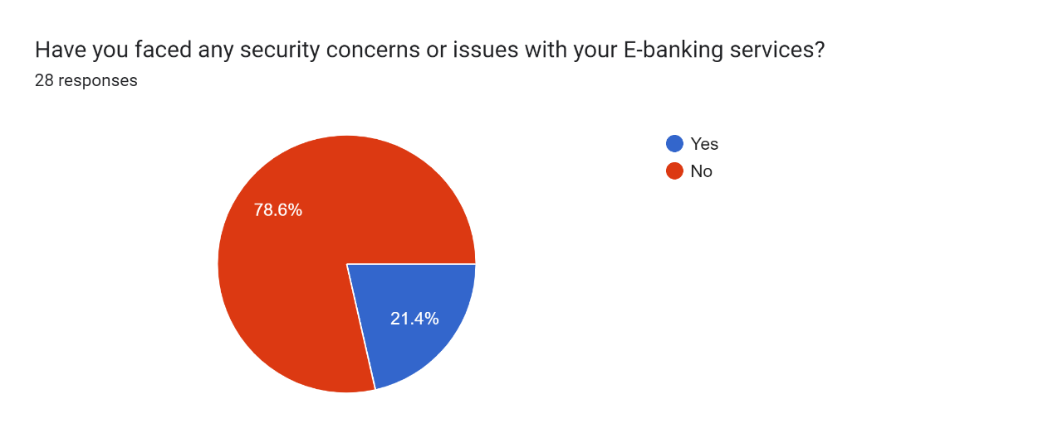

If you say yes, then which issue you faced?

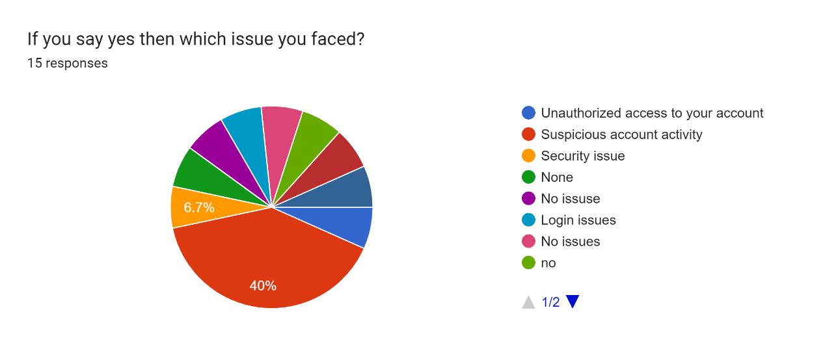

**Section D: Features and functionalities**

What features or functionalities do you find most useful in your E-banking platform?

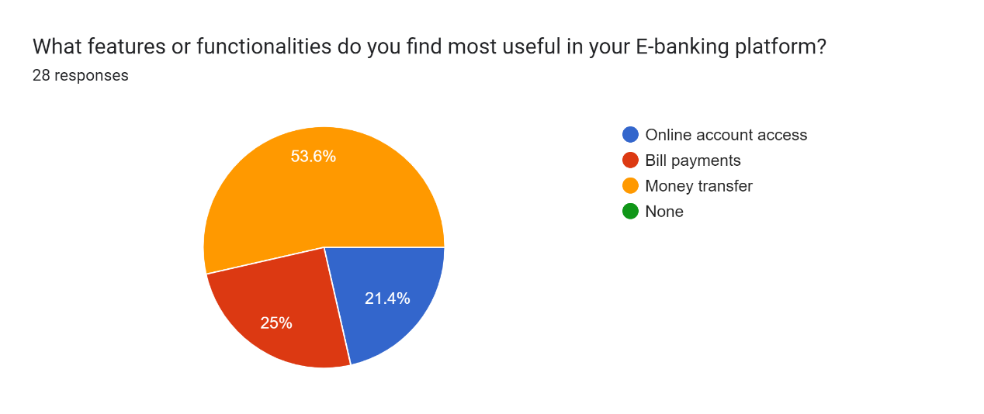

Are there any features or functionalities you wish your E-banking platform had but currently doesn’t offer?

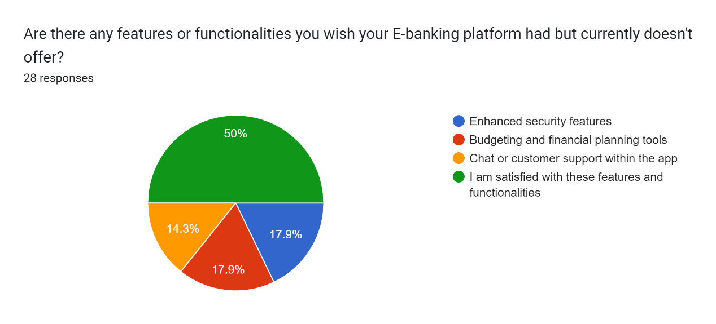

**Section E: Security Confidence**

How confident are you in the security of your E-banking transactions?

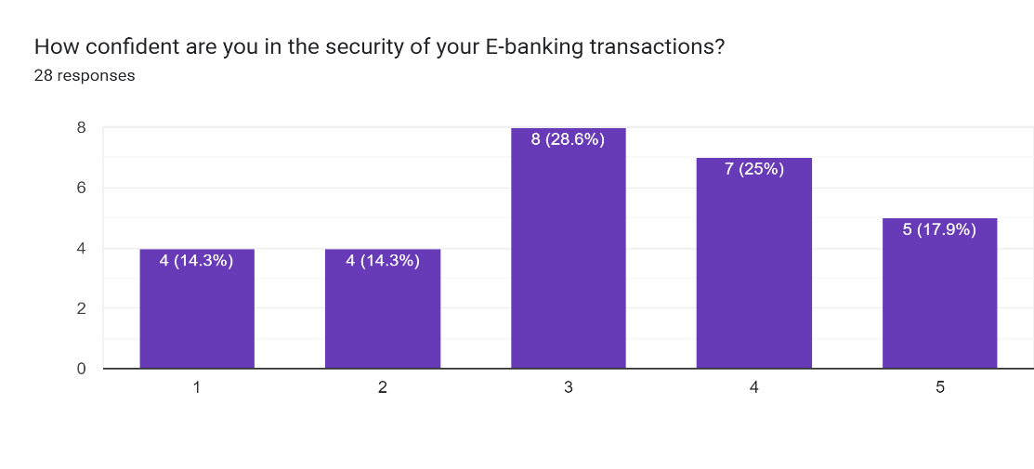

Have you ever experienced unauthorized access or fraudulent activity with your E-banking account?

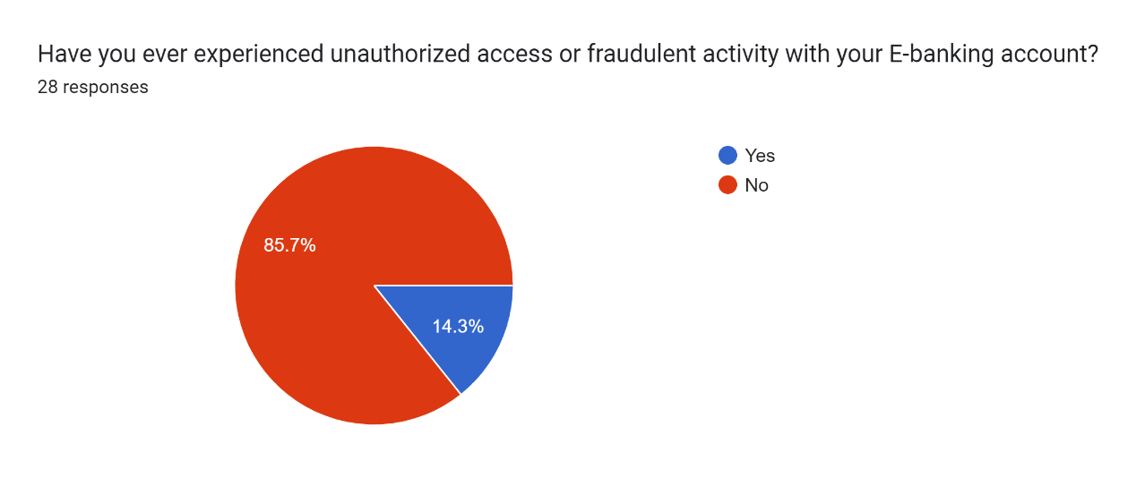

Do you think your bank provides adequate security measures, such as two factor authentication, to protect your E-banking?

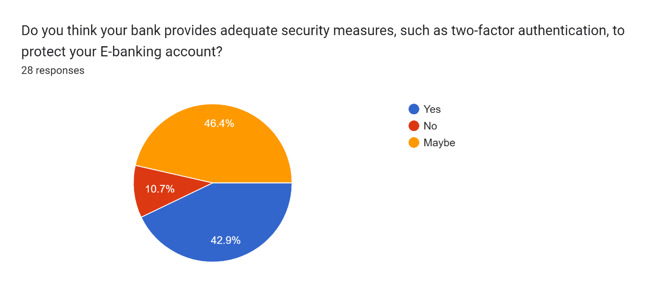

**Section F: Overall Experience**

Overall, how would you rate your E-banking experience with your current bank?

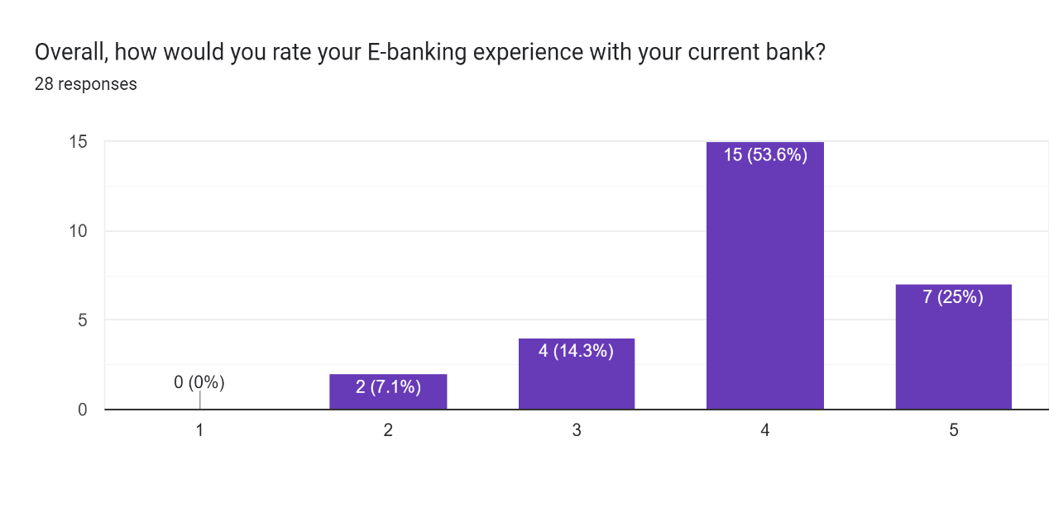

**RESULTS:**

**Demographic analysis:** The data collection shows that most of the respondents were of the age group 18-30 years of age (89% of respondents). While considering the gender of the respondents we see that both the genders represent a good strength of the banking customers (Males:42.9% and females: 57.2%). While looking at the Qualification of the respondents, majority of the respondents were Bachelor’s degree holders (71%), the second most important strength was 18% which was represented by those customers who were having college degree. It was interesting to see that (7.1%) respondents were those who were intermediate or below intermediate. The study on E-banking user experience reveals that approximately 71.4% of participants are students. Additionally, 11% are in full-time employment, indicating a diverse employment landscape among those surveyed in the realm of electronic banking.

**E-banking usage:** In E-banking usage duration, 42.9% have used services for less than six months, 25% for over two years. Meezan Bank is the primary choice for 25% of respondents. Usage frequency reveals 35% use E-banking rarely, 25% monthly, and 18% daily. Service-wise, 42.9% use it for money transfers, 28% for bill payments, and 17.9% for checking balances.

**User satisfaction and issue:** In evaluating user satisfaction with their E-banking platform's interface, 30% of respondents rated it 4 points, while 17.9% gave it the highest rating of 5 points. Concerning usability issues, the majority, 67.9%, reported no problems, while 32.1% acknowledged encountering challenges. Among those facing issues, 47.6% cited slow response time, 19% experienced error messages, and 9.5% reported other difficulties. Regarding security concerns, the majority, 78.6%, expressed no issues, while 21.4% indicated facing security-related challenges. Of those reporting issues, 40% mentioned concerns about suspicious account activity, while 10% stated having encountered no specific problems**.**

**Features and Functionalities:** The survey results reveal that 53.6% of respondents find money transfer to be the most useful feature in their E-banking platform, followed by 25% using it for bill payments, and 21.4% utilizing it for online account access. In terms of desired features, 50% of respondents express satisfaction with their current app features and functionalities. However, 17.9% wish for enhanced security features, and 14.3% express a desire for in-app chat or customer support. These insights provide valuable feedback on the most appreciated functionalities and potential areas for improvement within E-banking platforms.

**Security Confidence:** 28.6% of respondents rated their confidence in E-banking security at 3 points, 25% at 7 points, and 18% at 5 points. Regarding unauthorized access or fraudulent activity, 14.3% experienced issues, while 85.7% did not. Regarding bank-provided security measures, 42.9% believe their banks offer sufficient protection, 46.4% are uncertain, and 10.7% feel their banks lack adequate security measures.

**Overall Experience:** In assessing the overall E-banking experience with their current bank, 53.6% of respondents gave a rating of 4 points, while 25% assigned a higher rating of 5 points. These ratings provide an indication of the general satisfaction levels among the surveyed individuals regarding their E-banking experience with their current financial institution.

**DISCUSSION:**

**Demographic Analysis:** The study looked at who uses E-banking. Most people using it are between 18 and 30 years old. Both guys and girls use it a lot, and many have a Bachelor's degree. It's interesting that many users (71.4%) are students.

**E-banking Usage:** Some people have used E-banking for a short time (less than six months), while others have used it for a long time (over two years). Some use it rarely, some monthly, and some every day. Many use it for money transfers, bill payments, and checking balances.

**User Satisfaction and Issues:** Many users (67.9%) didn't have problems, but some (32.1%) faced challenges, like slow response time. Most users felt secure, but some (21.4%) had security issues, like concerns about suspicious activity.

**Features and Functionalities:** Users really like money transfer features. Half of them are happy with current app features, but some want better security and in-app support.

**Security Confidence:** Some users feel very confident about security, but others feel less sure. Some (14.3%) faced issues like unauthorized access. Some think their bank protects them well, but some are unsure.

**Overall Experience:** Most users (53.6%) gave a good rating, but some (25%) gave an even higher rating. This means many are happy, but improvements in security and features can make it even better.

**CONCLUSION:**

The data study shows a detailed view of user’s experience E-banking. It includes information about different types of people who use E-banking, how they use it, and if they like it. Some people are very happy and feel safe, but others find problems with how easy it is to use and worry about safety. We also learned about the things users want in E-banking.

What we found is that E-banking needs to get better. The way it looks and works should be improved, and it should be made even more safe. This is important so that everyone using E-banking has a good and safe experience. The data we collected can help banks make their services better and match what E-banking users want and need.

1. Sabi, H. M. (2014). Research trends in the diffusion of internet banking in developing countries. Journal of Internet Banking and Commerce, 19(2), 1.
2. Shao, G. (2007). The Diffusion of Online Banking: Research Trends from 1998 to 2006. Journal of Internet Banking & Commerce, 12(2)
3. Dong, J. (2008). Strategies for increased integration of online and in-branch services of banks in Canada. Journal of Internet Banking and Commerce, 13(3), 1.
4. A. Farooqui and P. Rajani, “E-Banking Issues & Challenges,” IOSR J. Bus. Manag., vol. 19, no. 10, pp. 31–39, 2017, doi: 10.9790/487X-1910063139.9
5. P. N. Dao, “Implementation of E-banking in Vietnam: Motivations and challenges – Case Company A,” 2014.
6. I. D. Adewuyi, “The Challenges of Internet Banking in Developing Countries,” Niger. Acad. Forum, vol. 9, no. 2, pp. 2–5, 2005.
7. Sannes, R. (2001). Self-service banking: value creation models and information exchange’, Informing Science, 4(3), 12–23. Reibstein, D.J. (2002). What attracts customers to online stores, and what keeps them coming back? Academy of Marketing Science Journal, 30, (4), 465–474.
8. Dandapani, K., Karels, G.V. and Lawrence, E.R. (2008). Internet banking services and credit union performance. Managerial Finance, 34, (6),437–447.
9. Sathye, M. (1999). Adoption of Internet banking by Australian consumers: an empirical investigation’, International Journal of Bank marketing, 17(7), 324-334.
10. Robinson, G. (2000), ‘Bank to the future’, Internet Magazine.
11. Centeno, C. (2004). Adoption of Internet services in the Acceding and Candidate Countries, lessons from the Internet banking case, Telematics and Informatics, .21, 293-315.